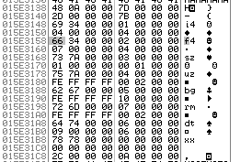

**DATA TYPES**

I4 – Integer 4, a 4 byte (32 Bit) Integer

F4 – Float 4, a 4 byte (32 Bit) floating point integer

UZ –

SZ – Null Terminated String, Hungarian Notation

**Theme Info Packet**

HEADER >> DWORD 0x08, DWORD, DWORD, DWORD